**Navigate Buy: Sistema Web Agregador de Compras Online Seguras e Simplificadas**

*Navigate Buy: Web System for Secure and Simplified Online Shopping Aggregation*

*Navigate Buy: Sistema Web Agregador de Compras en Línea Seguras y Simplificadas.*

**João Pedro Silva de Oliveira[1]**

*joao.olivera1210@etec.sp.gov.br*

**Luisa Santos Silva1**

*luisa.silva61@etec.sp.gov.br*

**Vinicius Valero Chabariberi1**

*vinicius.chabariberi@etec.sp.gov.br*

**Andreza Maria de Souza Rocha1**

*andreza.rocha2@etec.sp.gov.br*

**Jeferson Roberto de Lima1**

*jeferson.lima17@etec.sp.gov.br*

|  |  |
| --- | --- |
| **Palavras-chave:**  *Compra Online.*  *Consumidor.*  *Simplicidade.*  *Segurança.*  **Keywords:**  *Online purchasing.*  *Consumer.*  *Simplicity.*  *Security.*  **Palabras clave:**  *Compra en Línea.*  *Consumidor.*  *Simplicidad.*  *Seguridad.*  **Apresentado em:**  05 dezembro, 2024  **Evento:**  7º EnGeTec  **Local do evento:**  Fatec Zona Leste  **Avaliadores:**  Avaliador 1  Avaliador 2  [Desenho com traços pretos em fundo branco e letras pretas em fundo branco  Descrição gerada automaticamente com confiança média](https://creativecommons.org/licenses/by-nc-sa/4.0/) | **Resumo:**  Compra online é uma tarefa muito comum nos dias de hoje, e os perigos e riscos que um consumidor pode encontrar são diversos, causando uma preocupação ainda maior devido ao crescimento de consumidores online nos últimos anos. Com o objetivo de tornar a experiência em compras online uma tarefa mais rápida e segura, será desenvolvido um sistema web que irá utilizar as técnicas *web crawler* e *web scraping*. Para isso, será adotada uma abordagem exploratória qualitativa, com uma implementação que agrega diversos produtos de lojas renomadas, permitindo ao consumidor tomar decisões com base em comentários de sites de reclamação e gráficos. Além disso, a compra online se torna algo demorado quando se faz pesquisas para comparar preços de um produto em específico. Espera-se que o sistema web possa direcionar os consumidores para sites seguros e recomendados, facilitando a busca pelos menores preços entre variados sites, encontrando tudo em um só lugar. Portanto, pretende-se contribuir para avanço do comércio online oferecendo maior simplicidade e segurança para a principal peça desta engrenagem, o consumidor.  **Abstract:**  Online purchasing is a very common task nowadays, and the dangers and risks that a consumer can find are diverse, causing even greater concern due to the increase in online consumers in the last few years. With the aim of this work being to make online purchasing a fast and secure task, it will be necessary to develop a web system that will use web crawlers and web scraping techniques. For that, an exploratory qualitative approach will be adopted, implementing an aggregation of different products from renowned shops, allowing consumers to make decisions based on comments from complaint websites and charts. Furthermore, online purchasing becomes time-consuming when searching to compare prices of a specified product. As a result, we expect that the web system can direct consumers to secure and recommend sites, making it easier to search for the lowest prices among different sites, finding everything in one place. Therefore, the pretend is to contribute to the advancement of online purchasing by offering greater simplicity and security to the principal part of this gear, the consumer.  **Resumen:**  La compra en línea es una tarea muy común hoy en día, y los peligros y riesgos que un consumidor puede encontrar son diversos, causando una mayor preocupación debido al crecimiento del número de consumidores en línea en los últimos años. Para mejorar la experiencia de compra en línea sea más rápida y segura, se desarrollará un sistema web que utilizará técnicas de *web crawler* y *web scraping*. Para ello, se adoptará un enfoque exploratorio cualitativo, con una implementación que agrupa productos de tiendas reconocidas, permitiendo al consumidor tomar decisiones basadas en comentarios de sitios de reclamaciones y gráficos. Además, comprar en línea puede ser una tarea lenta cuando se busca comparar precios de un producto específico. Se espera que el sistema web dirija a los consumidores a sitios seguros y recomendados, facilitando la búsqueda de los mejores precios en varios sitios, reuniendo todo en un solo lugar. Por lo tanto, se pretende contribuir al avance del comercio en línea, ofreciendo simplicidad y seguridad para el principal actor de este proceso: el consumidor. |

1. **Introduction**

Navigate Buy focuses on the development of a web system that seeks to ensure and simplify the consumer’s experience with online shopping. According to the E-Commerce Brazil (2024) website, e-commerce is intended to grow by R$ 349 billion to R$ 557 billion in the interval between 2023 and 2027, pointing to the transition of consumption patterns. With this increase, the need for tools that make online shopping more secure and simplified has become crucial.

Despite the facility and accessibility of online shopping, consumers face difficulty in the analysis of the best offers and security verification of shopping websites. In line with Bolzani (2022), a survey carried out together with Opinion Box made by Octadesk showed that 73% of consumers declare that the prices of the internet are more accessible. However, pursuant to Faustino and Lobato (2023), a review conducted by the Brazilian Forum on Public Security (FBSP) shows that, in 2022, there was an elevation of 65.2% of online fraud.

Faced with this problem, the central hypothesis is the implementation of a web aggregator system of online shopping that makes it easier for the consumer’s decision-making, integrating the analysis of e-commerce and its respective products, presenting different prices and ratings for better comparison, currency conversions in real time, and more efficient security on its purchases.

Thus, the general objective is to develop a web system that allows consumers to compare products and prices between different verified e-commerce sites, searching for greater security in their purchases, analyzing the current reviews of many regulations of variable products based on reviewing websites, and being able to see the currency conversion in real time for better accessibility. Among the specified objectives are included:

* Research about the difficulties of consumers in their online shopping process;
* Analyze the main requirements of a web system that aims to facilitate the difficulties faced by the consumers;
* Provide the currency conversion in real time, explaining how this facilitates the transparency of prices and reduces the consumer’s uncertainty;
* Implement an efficient web application, providing relevant information, and helping to minimize the adversities faced by the consumers;
* Explore the impact of price and reviewing rating comparisons in decision-making.

In view of this, the methodology adopted included qualitative exploratory quantitative research to investigate the difficulties of consumers and the impact on which a web aggregator system of online shopping is secure and simplified. Statistical data were collected and analyzed for the development that attends to the identified needs, providing an efficient tool for decision-making at online shopping.

In the successor chapters, every step of development and theoretic reasoning of Navigate Buy will be presented, supported by several relevant authors in the area, like Guedes (2018), who will provide descriptions about the documentation and modeling of the system; Milani (2006), who will address the database management; Mckinney (2018), who will explore the programming language Python that has the central role in the project development; and Mitchell (2019), who will address the definition of the Web crawler, one of the main technologies of the application.

1. **Theorical Foundation**

In this section, the research problem that originated the need for the web system is designated, as well as the technologies adopted for its development, providing the essential theoretical foundation for the Navigate Buy conception.

# **2.1 Difficulty in secure and simplified online shopping searches**

According to Sé (2023), research made by the consultancy Offerwise in January 2023 showed that out of ten Brazilians, nine search online before doing a buying. This reflects the increase in adoption of the online ambience, with individuals dedicating time to searching for finding out what they desire.

In view of this, as addressed by Dias and Hemais (2015), despite the increase of inclusion of people in virtual ambience, there are still fears related to security and privacy questions. Therefore, the focus is attending to the consumer needs and reducing their adversities in online shopping, providing more facility in the search of offers, and better security.

# **2.2 HTML**

According to Cardoso (1999), Hypertext Markup Language (HTML) is a language based in text archives that can be edited by a program.

Pursuant to Freeman and Freeman (2006), a browser has the function to request an HTML page from a server, receiving it and displaying it in a window. The HTML reports to the browser everything about the content and the page structure, constituted by tags.

# **2.3 CSS**

In line with Quierelli (2012), Cascading Style Sheets (CSS) edit the visual appearance of web page content, adding background colors, styling text, and formatting images.

And, as noted by Jobstraibizer (2009), CSS is used to define the presentation of documents written in a markup language, such as HTML.

# **2.4 JavaScript**

As addressed by Flanagan (2013), the programming language JavaScript (JS) is widely used, being essential to element interaction and having a vast library of utilities.

According to Stefanov (2011), being essential for the interactivity of elements, JavaScript operates between the client side, which is the visible part on the page, and the server side, responsible for processing information within a system.

Figure 1, shown below, illustrates an example where a review form was created in three main steps. First, HTML was used to structure the content, including the texts review, name, email, and comments, along with the submit button, next, CSS was applied to style the layout, defining colors, rounded borders, and spacing between elements, resulting in a well-organized and visually pleasing design and finally, JavaScript would be responsible for adding interactivity, such as field validation to ensure the entered data is correct, and displaying confirmation or error messages after form submission.

Figure 1 - Example of application with HTML, CSS, and JavaScript

Source: From the author (2024)

As soon as the submit button is pressed, an alert appears on the screen, as shown in Figure 2.

Figure 2 - Result of alert box with JavaScript

Source: From the author (2024)

# **2.5 TypeScript**

According to Adriano (2021), Microsoft maintains and develops TypeScript, a JavaScript coding preprocessor. It uses principles like JavaScript, however, the advantage concentrates on preventing issues in a code.

# **2.6 React**

In accordance with Soares (2023), React is a library inherited by JavaScript, having its main purpose the front-end development, bringing with itself the decrease of the code lines in applications.

# **2.7 Python**

As mentioned by Mckinney (2018), Python is a programming language used in script functions, driving efficiency with its structure of simple coding and dynamic typing.

# **2.8 Web Crawler**

According to Mitchell (2019), the Web Crawler, which translates to "*rastreadores da* web" in Brazilian vernacular language, is essentially a tracking algorithm with a central element of recursion.

# **2.9 Web Scraping**

According to Farias, Angeluci, and Passarelli (2021), Web Scraping is the process of script creation, generally in Python, for extracting data in an automated and structured way for analysis and other purposes.

# **2.10 Tailwind**

As mentioned by Abba (2023), the Tailwind is a CSS framework that simplifies the page styling, enabling the CSS code to be inside HTML through its predefined classes.

# **2.11 Flask**

In line with Grinberg (2018), the Flask is a microframework written in Python, but it highlights that even though it is a small framework, this doesn't mean that it has fewer features than other frameworks. Considering the ease of understanding the code.

# **2.12 Scrapy**

According to Duke (2018), Scrapy is a framework that extracts a set of data as texts and numbers to manipulate and treat themselves. Everything that is available on the internet can be obtained.

As expressed by Gomes (2024), the extraction process takes place in an automated way, and the framework uses the Web Scraping technique together with Python, as it is an easy-to-use programming language.

The code represented in Figure 3 below demonstrates an example of coding written in Python, where public information from a webpage can be obtained through the technique of web scraping.

Figure 3 - Example of coding in Python with Scrapy

Source: From the author (2024)

Figure 4, presented below, displays the result of executing the code as shown in Figure 3. In this example, the code collects public information from a webpage, extracting relevant data such as titles and prices. The result presented in the figure reflects the data captured and structured from the page content, demonstrating the success of applying the web scraping technique to obtain and organize the information automatically extracted from a web system.

Figure 4 - Result of coding with Scrapy

Source: From the author (2024)

# **2.13 AwesomeAPI**

According to Butewicz (2022), it is possible to create a currency conversion system using the Python programming language and AwesomeAPI. He emphasizes that using this API is as straightforward as any other Python library.

# **2.14 Database and MySQL**

Pursuant to Zhao (2023), the database is a set of organized data, which aims to store information in in a computational system.

Date (2004) indicates that a Database Management System (DBMS) is used to manage one or more databases. It allows data modeling, making DBMSs crucial for organizing and manipulating data.

As characterized by Milani (2006), MySQL is a DBMS, which provides advantageous storage of data and information in a medium that is increasingly popular today.

# **2.15 UML**

According to Guedes (2018), Unified Modeling Language (UML) is a visual and modeling language based on the object-oriented paradigm, composed of diagrams with the objective of defining characteristics of a system to be applied.

As Pressman and Maxim (2021) state, this language has become the international standard for creating software of all types. Thus, understanding its elements allows you to specify and understand a system easily.

1. **Method**

The adopted method includes qualitative research which, according to Gil (2002), promotes a dynamic interaction between observation and interpretation, enriching the understanding of the studied phenomenon and favoring a more detailed organization of the work. The research aimed to investigate the difficulties faced by consumers and the impact of a web-based system for secure and simplified online shopping.

For the development of this project and the results of the theoretical framework, books, articles, news, and websites were used. Additionally, for the practical implementation, the technologies discussed in the previous section were employed, including programming.

# **3.1 Interfaces of the Application**

This section presents the practical implementation achieved through the development of the web system, highlighting the created interfaces and the implemented functionalities.

In Figure 5, we can observe the first interface, which corresponds to the registration of consumers.

Figure 5 - "Registration" interface

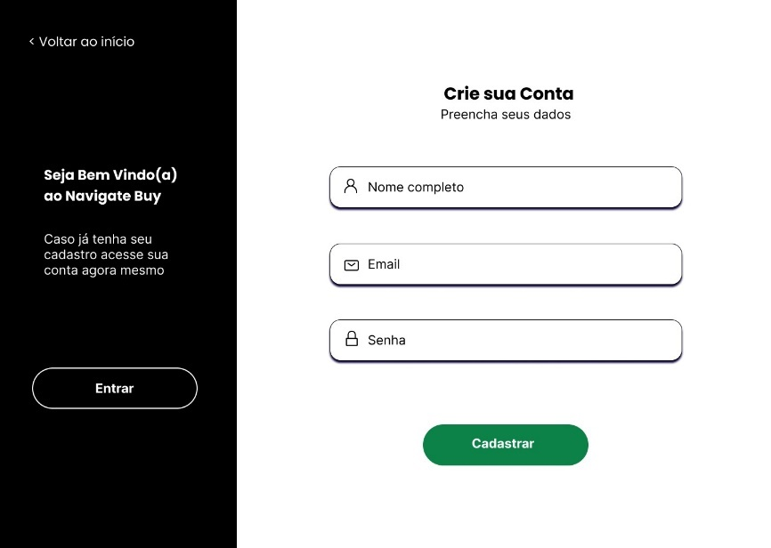

Source: From the author (2024)

Next, after the consumer completes the registration, they can log in on the screen presented in Figure 6 to access specific functionalities that will be described later.

Figure 6 - "Login" interface

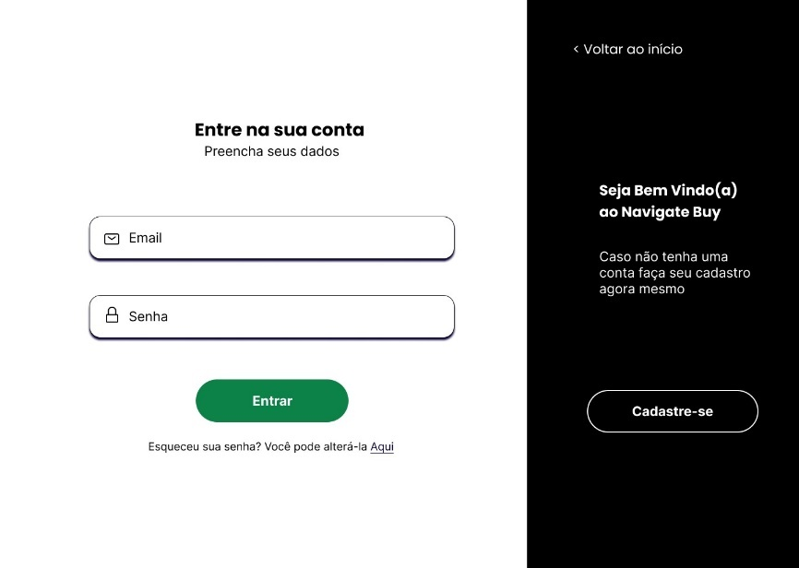

Source: From the author (2024)

In the interface represented in Figure 7, the consumer can view and edit their profile. This interface allows the user to update their personal information, such as name, password, and profile picture.

Figure 7 - "Profile" interface

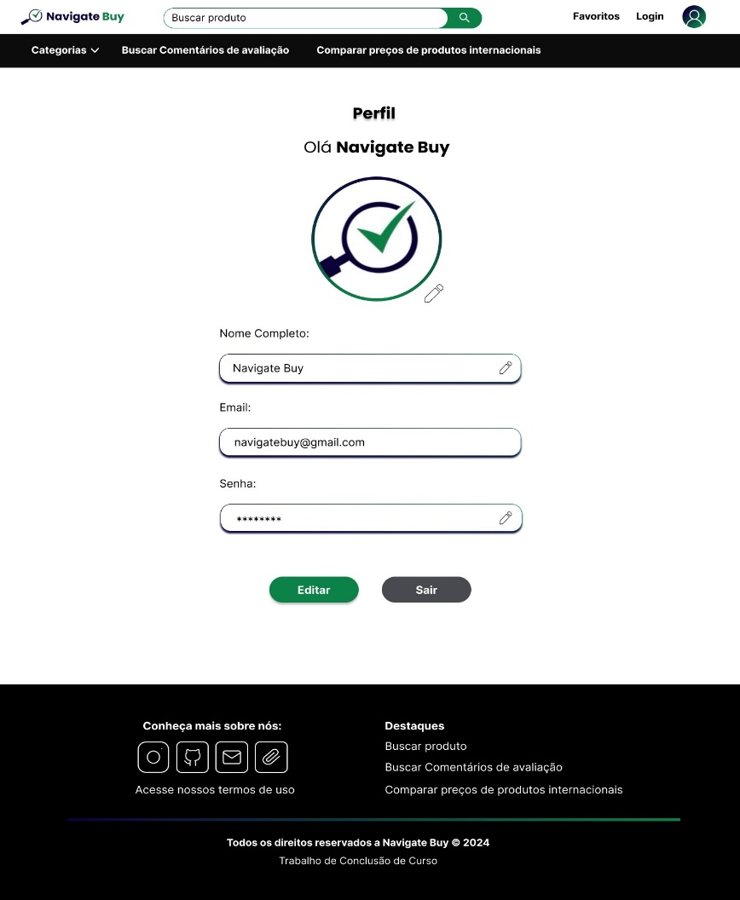

Source: From the author (2024)

In Figure 8, the main screen of Navigate Buy is presented, which does not require a login to access. This screen describes the main national stores from which data has been scraped, examples of key categories, and security recommendations. It includes a list of websites to avoid, such as those flagged by Procon SP, and advises checking if site links are secure using the Google Transparency Report for safer online shopping.

Figure 8 - "Home" interface

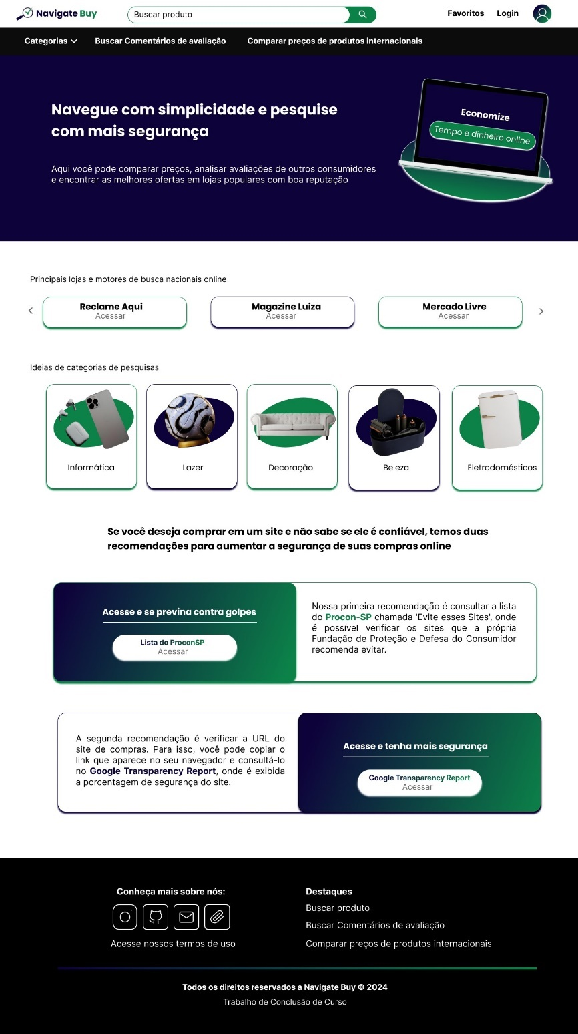

Source: From the author (2024)

Figure 9 showcases one of the main functionalities of the system that does not require a login. Consumers can search for products by category or by entering a specific name in the search bar. The results for the respective product are displayed from various popular national stores with secure URL hosts. Products can be filtered by order of highest relevance, lowest price, highest price, and highest rating. Additionally, a graph of the chosen filter is available, showing the highest and lowest values found based on the selected criteria.

Figure 9 - "Search product" interface

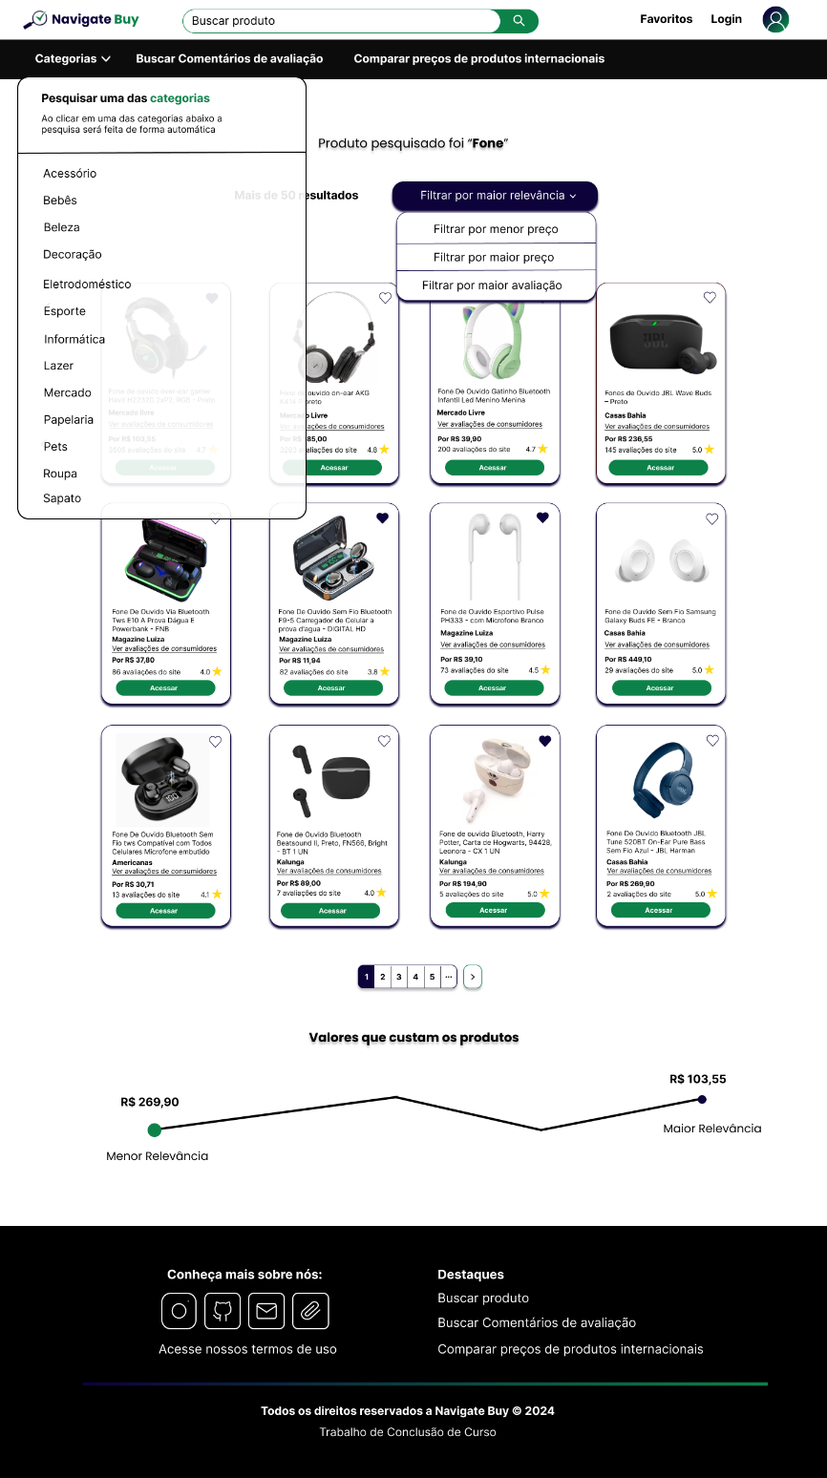

Source: From the author (2024)

If a consumer wishes to favorite any of the products they searched for, they must register and log into their account, as demonstrated in Figures 5 and 6. Figure 10 presents the interface for favorite products, where consumers can not only view the items added to their favorites list but also edit these preferences. Additionally, they have the option to receive email alerts regarding these products, adding reminders for any favorite products in their account.

Figure 10 - "Favorited products" interface

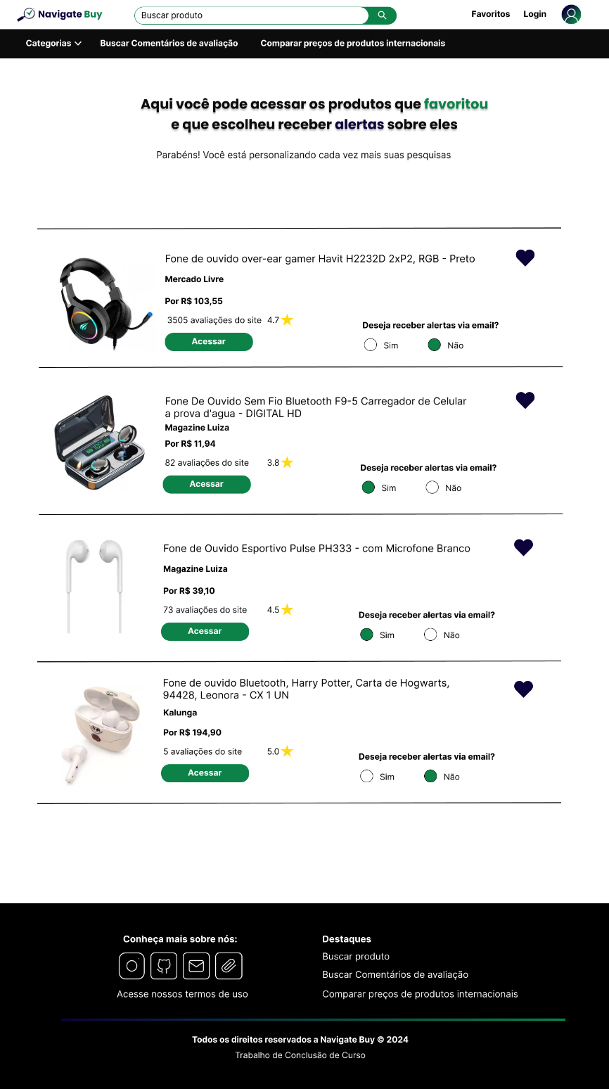

Source: From the author (2024)

Figure 11 represents another main functionality of the web system, which is to search for review comments. This feature allows consumers to search for a product and/or the name of the store from which they wish to find review comments that have been scraped and indexed from *Reclame Aqui*. Consequently, they can be directed to the appropriate page, where they can analyze whether the corresponding complaint has been resolved or if it still persists, potentially causing some type of harm to the buyer. This functionality is essential for assisting consumers in making more informed decisions before making an online purchase.

Figure 11 - "Search review comments" interface

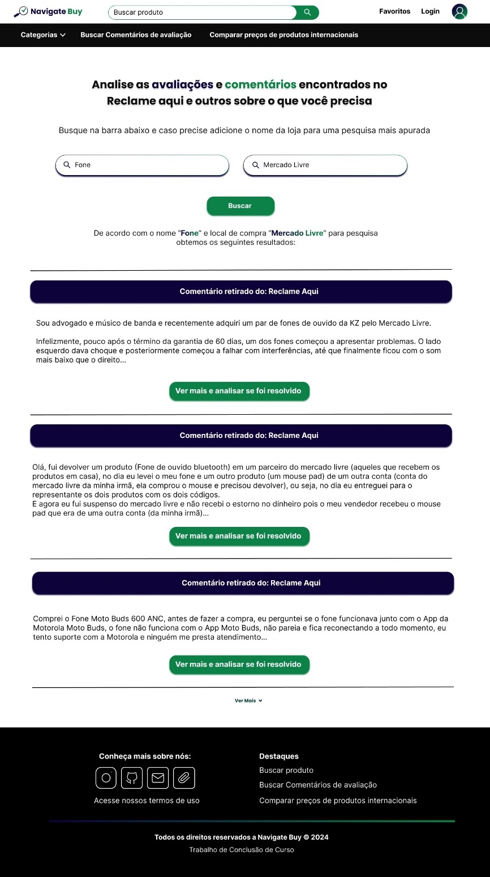

Source: From the author (2024)

As the final interface, Figure 12 illustrates the screen for comparing prices of international products, providing real-time currency conversion. This functionality allows for the analysis of different prices across various countries, as well as the calculation of import taxes and an explanation of how these calculations are performed and what import taxes are. Additionally, the interface presents ideas for international stores, detailing their continents and the currencies available in each.

Figure 12 - "Compare prices of international products" interface

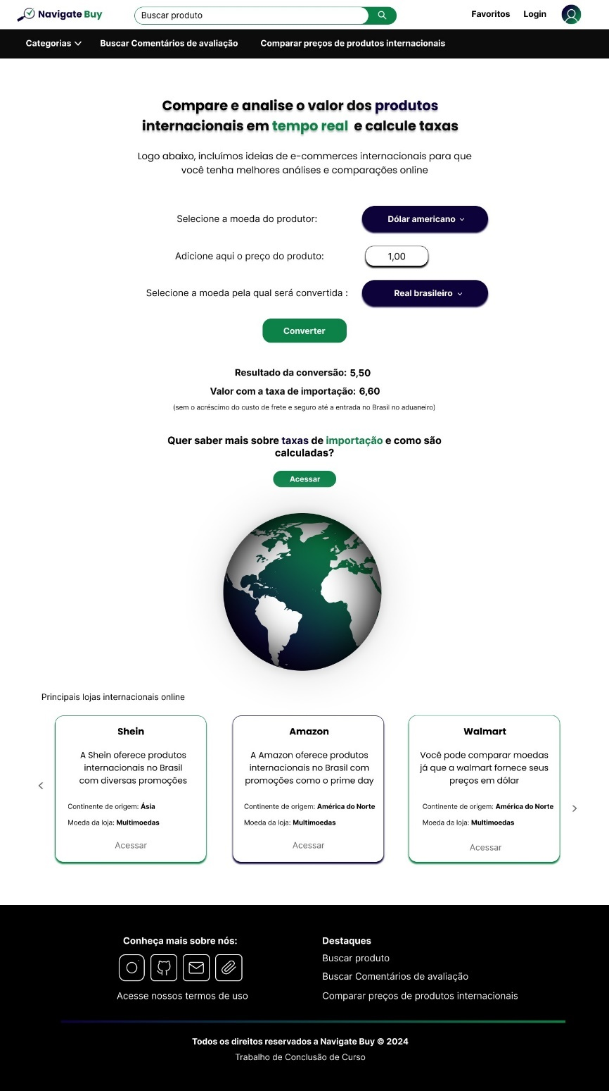

Source: From the author (2024)

1. **Results and Discussions**

Considering the analyses conducted, the main difficulties faced by online consumers when searching for offers in a safe and simplified manner were identified. With over 25 thousand offers available for analysis, Navigate Buy emerged, a system that centralizes these functionalities in a single environment, optimizing time and reducing costs for the target audience, in addition to facilitating safer decision-making. However, some factors limit the project; it is observed that the scope of data sources depends on integration with reliable websites, which can limit the comprehensive analysis of products. Furthermore, the use of web data extraction techniques faces access restrictions to certain websites, reducing the available options. Thus, it becomes necessary to expand access to partner sites and implement continuous data update strategies in order to enhance the accuracy and scope of the platform, increasingly meeting consumer needs.

1. **Conclusion**

After the development of the project, the relevance of the web system in the daily lives of online consumers became evident, especially in a scenario where e-commerce is rapidly growing. The objectives established at the beginning of this study were successfully completed, offering a solution to the results of the identified problem, where research showed that there are still challenges in searching for and comparing the best offers from various verified stores. This highlights the importance of implementing the web system as a crucial tool not only for future projections but also to meet the current demands of consumers, promoting continuous growth in the virtual environment.

Moreover, this project brings with it several positive consequences, such as optimizing the shopping experience and simplifying the search for more competitive prices, directly impacting the daily lives of consumers. However, it is essential to consider some obstacles, such as the need to expand the variety of stores included in the analysis and the rapid evolution of available technologies.

Therefore, this project contributes to both the academic sphere and the advancement of online shopping, facilitating the search for better prices and promoting innovation and digital infrastructure. Thus, for future investigations and implementations, it is recommended to explore technological innovations that can enhance the personalization of offers and the understanding of customer preferences on the internet.

**References**

ADRIANO, Thiago Silva. **Guia prático de TypeScript - Melhore suas aplicações JavaScript**. São Paulo: Casa do Código Editora, 2021. E-book.

CARDOSO, Carlos. **HTML 4 - Série Curso Básico & Rápido**. 1 ed. Rio de Janeiro: Axcel Books, 1999.

DATE, C. J. **Introdução a sistemas de bancos de dados**. 8. ed. Rio de Janeiro: Elsevier Editora, 2004.

FREEMAN, Elisabeth; FREEMAN, Eric. **Use a Cabeça! HTML com CSS e XHTML**. 2. ed. Rio de Janeiro: Alta Books, 2006.

FLANAGAN, David. **JavaScript:** O guia definitivo. 6 ed. Porto Alegre: Bookman, 2013.

GIL, Antonio. **Como Elaborar Projetos de Pesquisa**. 4 ed. São Paulo: Atlas, 2002.

GRINBERG, Miguel. **Desenvolvimento web com Flask:** Desenvolvendo aplicações web com Python. 1 ed. São Paulo: Novatec Editora. 2018. E-book.

GUEDES, Gilleanes T. A. **UML 2 - Uma Abordagem Prática**. 3. ed. São Paulo: Novatec Editora, 2018.

JOBSTRAIBIZER, Flávia. **Criação de sites com CSS**. 1 ed. São Paulo: Digerati Books, 2009.

MCKINNEY, Wes. **Python para análise de dados:** Tratamento de dados com Pandas, NumPy e IPython. 1 ed. São Paulo: Novatec Editora. 2018. E-book.

MILANI, André. **MySQL - Guia do Programador**. 1. ed. São Paulo: Novatec Editora, 2006.

MITCHELL, Ryan. **Web Scraping com Python**: Coletando mais dados da web moderna. 2. ed. Brasil: Novatec Editora, 2019.

PRESSMAN, Roger S; MAXIM, Bruce R. **Engenharia de software**: uma abordagem profissional. 9. ed. Porto Alegre: AMGH, 2021. E-book.

QUIERELLI, Davi A. **Criando Sites com Html-css-php:** Construindo um projeto iniciante. 1 ed. São Paulo: Clube de Autores, 2012.

SOARES, Adriano Mesquita (org.). **Tópicos especiais em engenharia:** Inovações e avanços tecnológicos. 1 ed. São Paulo: AYA Editora, 2023. E-book.

STEFANOV, Stoyan. **Padrões JavaScript**. 1 ed. São Paulo: Novatec Editora, 2011.

ZHAO, Alice. **SQL - Guia Prático**: um guia para o uso de SQL. 4. ed. São Paulo: Novatec Editora, 2023.

DIAS, Juan Pablo da Silva; HEMAIS, Marcus Wilcox. Consumidores de baixa renda e compras on-line: Receios em consumir pela internet. **REGE - Revista de Gestão**, São Paulo, v. 22, n. 2, p. 115-132, jan./mar. 2015. Available at: https://www.sciencedirect.com/science/article/pii/S1809227616300960. Accessed: 03 may. 2024.

FARIAS, Marcello Tenorio de; ANGELUCI, Alan César Belo; PASSARELLI, Brasilina. Web scraping e ciência de dados na pesquisa aplicada em comunicação: um estudo sobre avaliações online. **Revista Observatório**, Palmas, v. 7, n. 3, p. 1-22, jul./sep. 2021. Available at: https://repositorio.usp.br/item/003093096. Accessed: 29 may. 2024.

ABBA, Ihechikara. **Como Usar o Tailwind CSS para Desenvolver Rapidamente os Sites da Snazzy**. 2023. Available at: https://kinsta.com/pt/blog/tailwind-css/. Accessed: 23 apr. 2024.

BOLZANI, Isabela. **61% dos brasileiros compram mais pela internet do que em lojas físicas, aponta estudo**. G1globo, 2022. Available at: https://g1.globo.com/economia/noticia/2022/12/14/61percent-dos-brasileiros-compram-mais-pela-internet-do-que-em-lojas-fisicas-aponta-estudo.ghtml. Accessed: 24 mar. 2024.

BUTEWICZ, Thanael. **Utilidades Python:** Obtendo conversão de moedas. Casa do desenvolvedor. 2022. Available at: https://forum.casadodesenvolvedor.com.br/topic/45430-utilidades-python-obtendo-conversão-de-moedas. Accessed: 23 may. 2024.

DUKE, Justin. **Como Fazer Crawling em uma Página Web com Scrapy e Python 3**. 2018. Available at: https://www.digitalocean.com/community/tutorials/como-fazer-crawling-em-uma-pagina-web-com-scrapy-e-python-3-pt. Accessed: 26 may. 2024.

E-COMMERCE BRASIL. **O impulso do e-commerce no Brasil**: perspectivas até 2027. 2024. Available at: https://www.ecommercebrasil.com.br/artigos/o-impulso-do-e-commerce-no-brasil-perspectivas-ate-2027. Accessed: 04 jun. 2024.

GOMES, Ana Maria. **O que é Web Scraping e Como Utilizar com Python**. 2024. Available at: https://hub.asimov.academy/tutorial/o-que-e-web-scraping-e-como-utilizar-com-python/. Accessed: 31 may. 2024.

FAUSTINO, Marco; LOBATO, Gisele. **Golpes virtuais crescem 65% com brasileiros passando mais tempo na internet**. Terra, 2023. Available at: https://www.terra.com.br/noticias/checamos/golpes-virtuais-crescem-65-com-brasileiros-passando-mais-tempo-na-internet,5b5a67f228cff03faf6084e2fc39eaa6oq7kkt7m.html. Accessed: 28 mar. 2024.

SÉ, Letícia. **Nove** **em dez brasileiros pesquisam online antes de comprar, diz Google**. Globo, 2023. Available at: https://revistapegn.globo.com/negocios/noticia/2023/03/nove-em-dez-brasileiros-pesquisam-online-antes-de-comprar-diz-google.ghtml. Accessed: 27 mar. 2024.

The contents expressed in the work, as well as the copyright of figures and data, along with their spelling and formatting revisions, are the sole responsibility of the author(s).

1. ETEC Zona Leste